The common good for all should be the default over individual gain.

Importance of

* Transparency
* Open communication
* Integrity
* Trust with students
* Rooted in care. The levels of care.

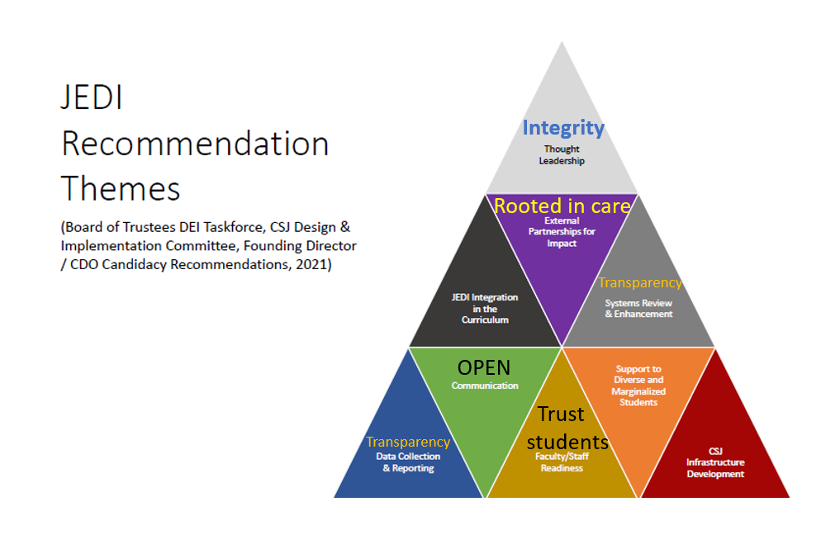

1. **Capacity Needs**

Readiness of Faculty

* Open communication
* Bottleneck of control at the top- what should teaching be and learning feel like.
* Trust with students
* Mindset of suspicion of students cheating > privacy & surveillance tools

*Sustainable improvement: allow others to make the choice to change.*

Infrastructure

* People need to realize the technologies and the systems that are leveraged against marginalized people first, will eventually harm everyone.
* Reluctance to call out harm, then it becomes accepted and institutionalized

**b. Support to diverse /marginalized students** or JEDI integration into the curriculum

Examples: levels of care

* Greeting them into our community (learning)-how is that done? Welcoming
* What expectations do we put on them?
  + They must have a certain level of means and it is not always equitable. Buying course materials, the ability to use technology. (phones vs laptops.
* Giving them a voice in their education. Mindset of control. (We know better)
* Privacy and surveillance

**c.** Data collection or **Communication** needs most attention

Transparency to drive communication. Data will follow

* Marketing
* Opening library, textbooks, etc.
* AI instead of personalize touch> funneling education to a dehumanized approach

**d**. Organizational systems for review and potential JEDI enhancements

* **Culture** >procedures> policies
* Who is at the table? Dissenting voices are left in the margins.

**e**. JEDI thought leadership strategies

* [Open Education Conference](https://openeducationconference.org/2022)
* Alignment of our strategic goals with the [UNESCO and Sustainable Development Goals](https://en.unesco.org/sustainabledevelopmentgoals) SDG#4 [Quality Education](https://unesdoc.unesco.org/ark:/48223/pf0000245656)
* Equity Unbound <https://onehe.org/equity-unbound/>
* [Equity Unbound as Critical Intercultural Praxis](https://edtechbooks.org/jaid_10_4/equity_unbound_as_cr)
* Paulo Freire [Critical pedagogy and quality education (UNESCO SDG-4): the legacy of Paulo Freire for language and intercultural communication.](https://www.tandfonline.com/doi/full/10.1080/14708477.2021.1962900)